Lab Objective

* Encrypt files with EFS

**Lab Procedures**

# Encrypting Files with EFS

**1.** Log in to Server01 as the **Contoso\administrator** user account. The Server Manager console opens.

**2.** On Server01, create a **C:\Data** folder.

**3.** Create a text file in the C:\Data folder called **test.txt** file. Type your name in the file, close the file, then click Save to save the changes.

**4.** Right-click the C:\Data folder, and then click Properties. The Properties dialog box opens.

**5.** On the General tab, click Advanced. The Advanced Attributes dialog box appears as shown in Figure 6-1.

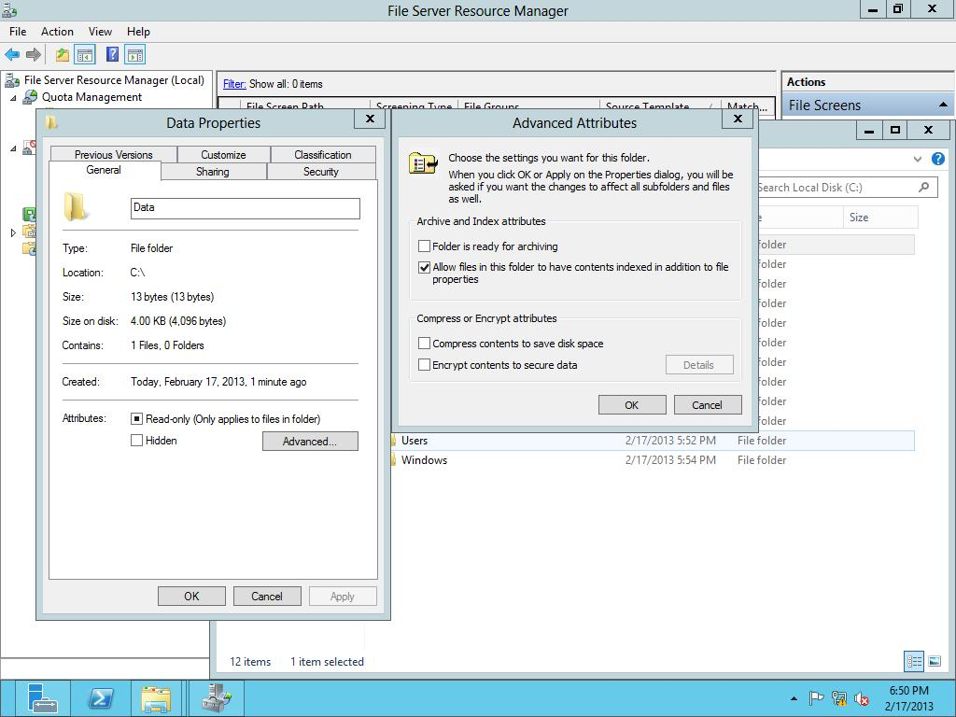

Figure 6-1

Configuring advanced attributes

**6.** Click to select *Encrypt contents to secure data*. Click OK to close the Advanced Attributes dialog box.

**7.** Click OK to close the Properties dialog box.

**8.** When Windows asks you to confirm the changes, click OK.

|  |  |
| --- | --- |
| Question 1 | What color is the C:\Data folder. Green |

|  |  |
| --- | --- |
| Question 2 | Is the test.txt file in the C:\Data folder also encrypted? Yes |

**9.** Right-click the C:\Data folder and click Properties. The Properties dialog box opens.

**10.** Under the General tab, click Advanced. The Advanced Attributes dialog box opens.

**11.** Clear the *Encrypt contents to secure data* check box. Click OK to close the Advanced Attributes dialog box.

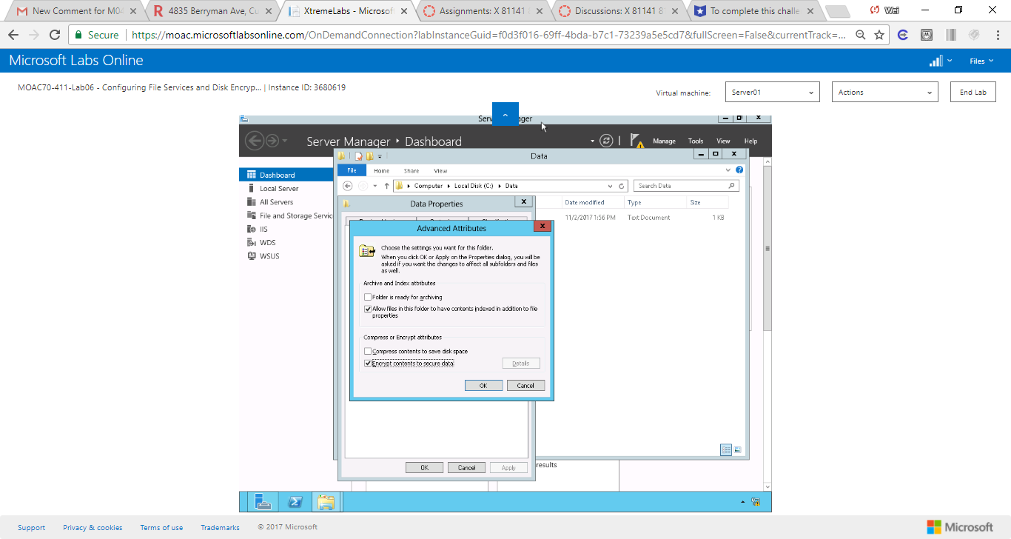

Figure Clear the Encrypt contents to secure data check box. Click OK to close the Advanced Attributes dialog box.

**12.** Click OK to close the Properties dialog box.

**13.** When it asks to confirm attribute changes, click OK.

**14.** From Server01, log off as administrator.

# Sharing Files Protected with EFS with Other Users

**1.** Log into RWDC01 as **contoso\administrator**, Server Manager starts. Open the Tools menu and click Active Directory Users and Computers. The Active Directory Users and Computers console opens.

**2.** Right-click the Users node, click New, then click User.

**3.** Create a new user with the following parameters:

First Name: **User1**

User logon name: **User1**

Click Next.

**4.** For the Password and Confirm password text boxes, type **Password01**. Click to select Password never expires. When an Active Directory Domain Services dialog box appears, click OK. Click Next.

**5.** When the user is ready to be created, click Finish.

**6.** Under the Users node, double-click User1. The User1 Properties dialog box opens.

**7.** Click the Member Of tab.

**8.** Click the Add button. When the Select Groups dialog box opens, type **domain admins** and click OK.

**9.** Click OK to close the User1 Properties dialog box.

**10.** On Server01, log in as **contoso\User1** with the password of **Password01**.

**11.** Open the C:\Data folder, right-click the test.txt file and click Properties.

**12.** On the General tab, click Advanced. The Advanced Attributes dialog box opens.

**13.** Click *Encrypt contents to secure data*. Click OK to close the Advanced Attributes dialog box. Click OK to close the test Properties dialog box.

**14.** When it asks if you want to encrypt the file and its parent folder, click OK.

**15.** If an Access Denied message appears, click Ignore, click Continue, click OK, and click Ignore. Click OK. If an Access Denied message appears again, click Ignore All. When you are done, the test.txt file should be green.

**16.** On Server01, log out as User1 and log in as **Contoso\Administrator**.

**17.** Open the C:\Data folder.

**18.** Double-click to open the Test.txt file.

|  |  |
| --- | --- |
| Question 3 | What error message did you get? Access is denied |

**19.** Click OK to close the message, and then close Notepad.

**20.** Right-click the test.txt file and click Properties.

**21.** Click the Security tab.

|  |  |
| --- | --- |
| Question 4 | What permissions does Administrator have? Full control |

|  |  |
| --- | --- |
| Question 5 | Why was the contoso\administrator not able to open the file? The file was encrypted |

**22.** Go back to the General tab, click the Advanced button, clear the Encrypt check box, and then click OK.

**23.** Click OK to close the test Properties dialog box. When prompted for administrator permissions, click Continue. After the Access Denied dialog is displayed, click Cancel to close it.

|  |  |
| --- | --- |
| Question 6 | Were you able to decrypt the file? No, I wasn’t |

**24.** On Server01, log off as Administrator and log on as **User1**.

**25.** Open the C:\Data folder.

**26.** Right-click the test.txt file and click Properties. The Properties dialog box opens.

**27.** Click the Advanced button to open the Advanced Attributes dialog box.

**28.** Click to deselect the *Encrypt contents to secure data* check box, and click OK.

**29.** Click OK to close the Properties dialog box. When it asks you to provide administrator permission to change these attributes, click Continue.

**30.** Log off as User1 and log on as **contoso\administrator**.

**31.** Open the C:\Data folder.

**32.** Right-click the test.text and click Properties.

**33.** Click the Advanced button to open the Advanced Attributes dialog box.

**34.** Click to select the *Encrypt contents to secure data* check box. Click OK to close the Advanced Attributes dialog box.

**35.** Click OK to close the Properties dialog box. When it asks to apply to the folder and its contents, click OK.

**36.** Right-click the test.txt folder and click Properties. Click the Advanced button to open the Advanced Attributes dialog box.

**37.** Click the Details button. The User Access to test.txt dialog box opens as shown in Figure 6-2.

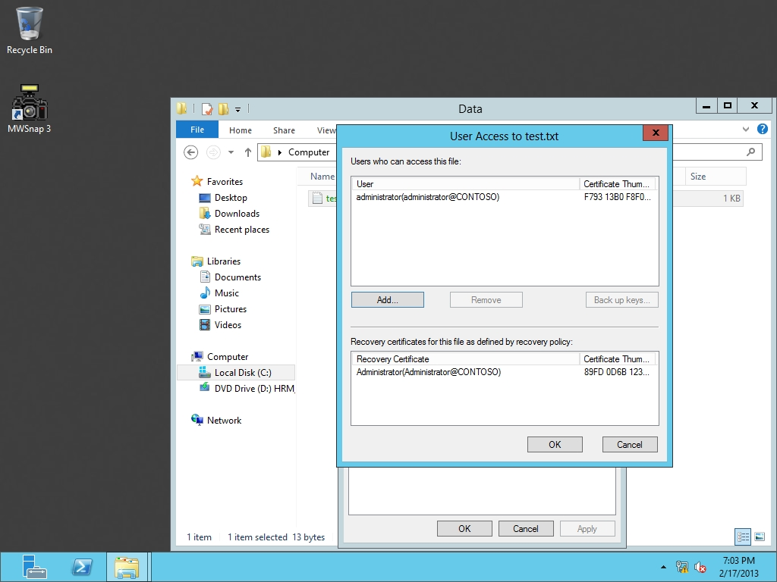

Figure 6-2

Certificate details for test.txt file

**38.** Click the Add button. When the Encrypting File System dialog box (as shown in Figure 6-3), click User1 and click View Certificate.

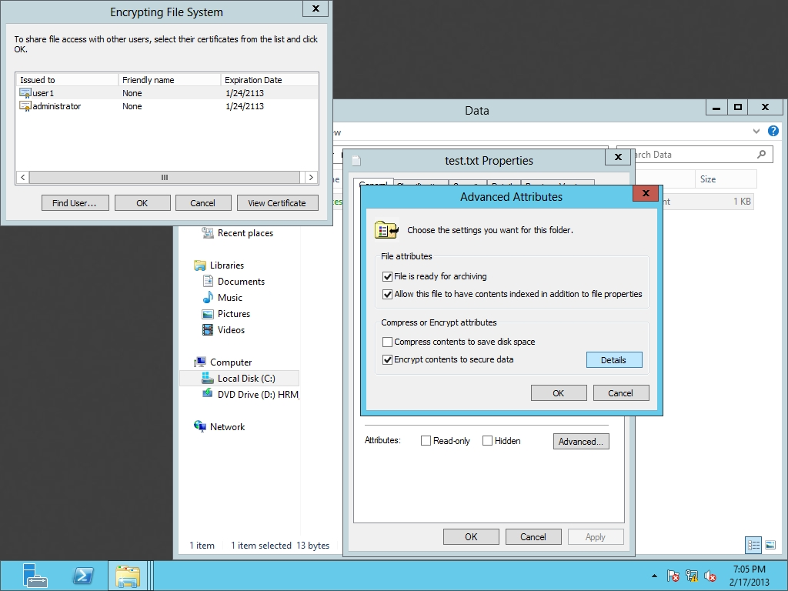

Figure 6-3

EFS certificates for test.txt

**39.** When the Certificate dialog box opens, click the Details tab.

|  |  |
| --- | --- |
| Question 7 | What is the Certificate used for? Hint: Look at the Enhanced Key Usage field**. Encrypting files** |

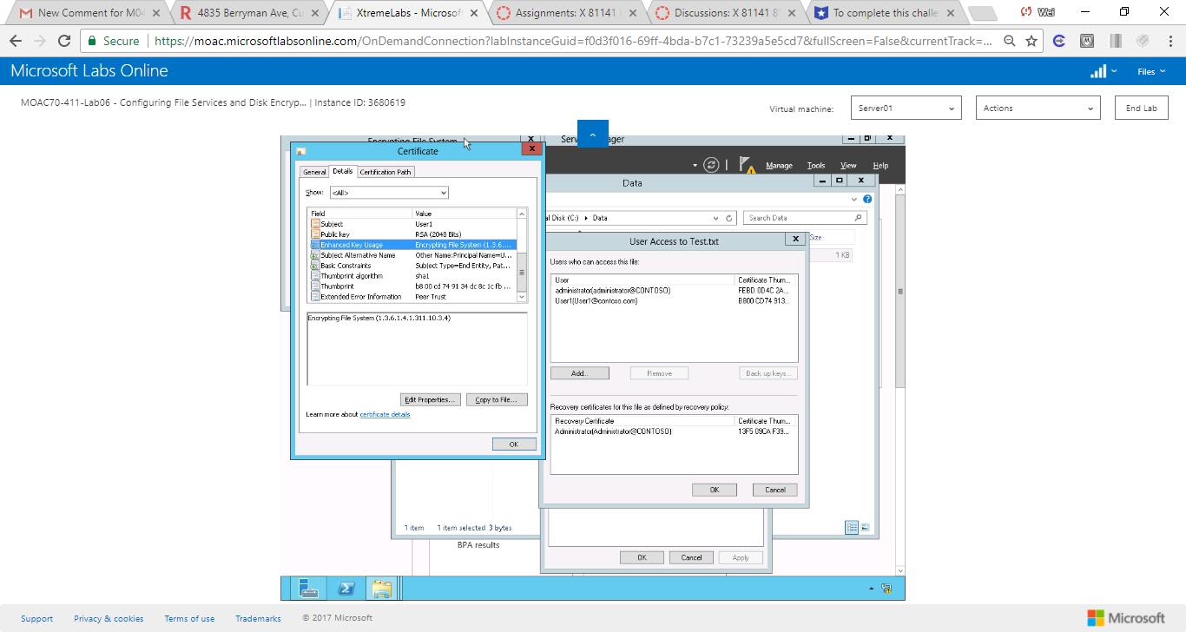

Figure When the Certificate dialog box opens, click the Details tab

**40.** Click OK to close the Certificates dialog box.

**41.** Click OK to close the Encrypting File System dialog box.

**42.** Take a screen shot of the User Access dialog box by pressing Alt+Prt Scr and then paste it into your Lab08_worksheet file in the page provided by pressing Ctrl+V.

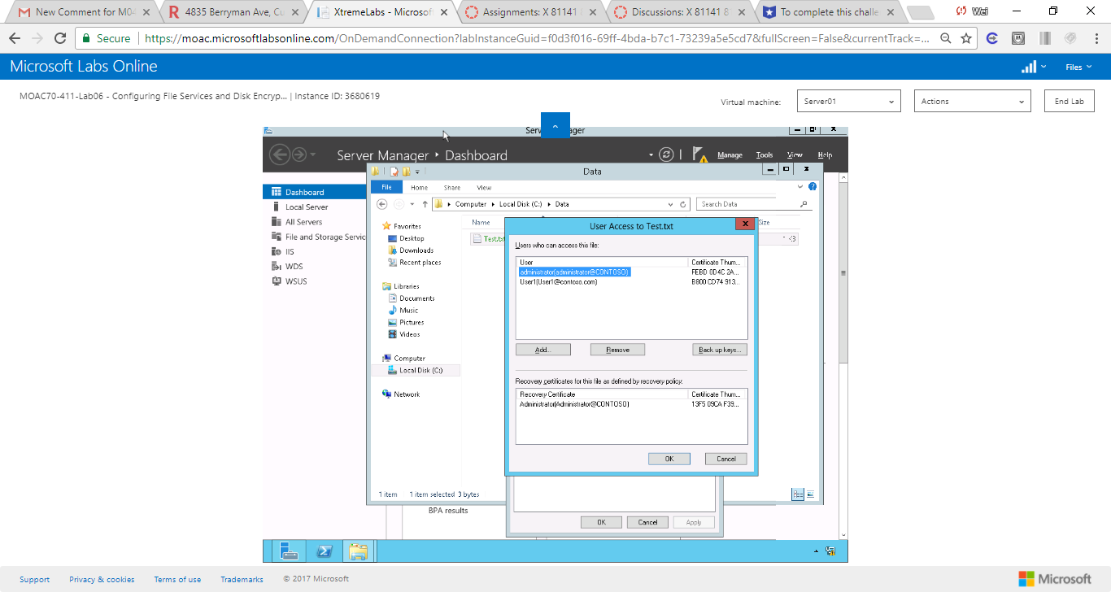

Figure When the Certificate dialog box opens, click the Details tab

**43.** Click OK to close the User Access to test dialog box, click OK to close the Advanced Attributes dialog box, and click OK to close the test properties dialog box.

**44.** On Server01, sign out as Administrator and log in as **User1**.

**45.** Open the C:\Data folder and open the test.txt file.

|  |  |
| --- | --- |
| Question 8 | Were you able to open the file? Yes |

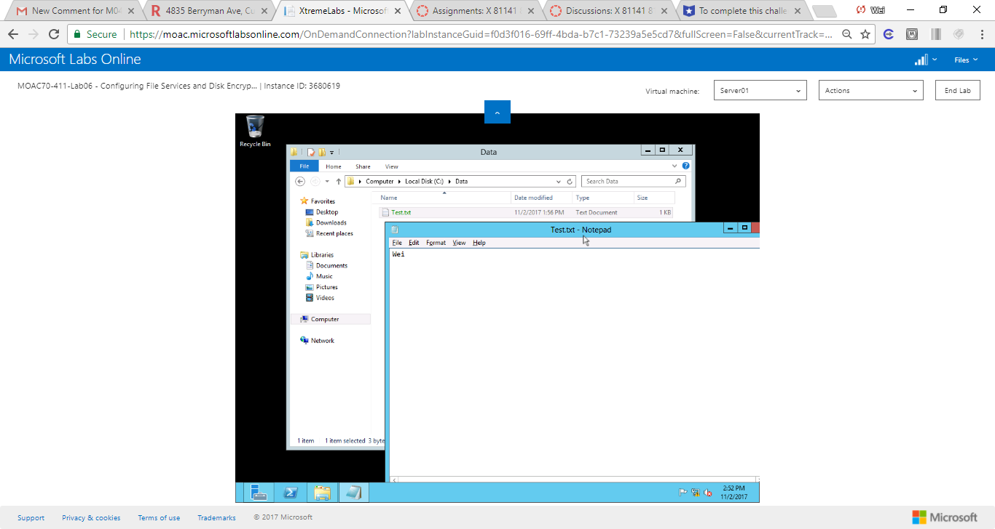

Figure User1 is still able to view the file that is encrypted by Admin

**46.** Close the test.txt file.

**47.** On Server01, sign out as User1.

**Lab Summary**

During this exercise, I encrypted a file using Encrypting File System (EFS), which is a built-in feature of NTFS. I can enable EFS through Properties ->Advanced->Encrypt contnets to secure data. I can allow other users to view an EFS file that I encrypted by adding them in Encrypt contents to secure data. Properties ->Advanced->Encrypt contents to secure data->details->Add… as shown below.

